TRAK: TalkWalker Social Search is a good replacement for Topsy for social media analytics

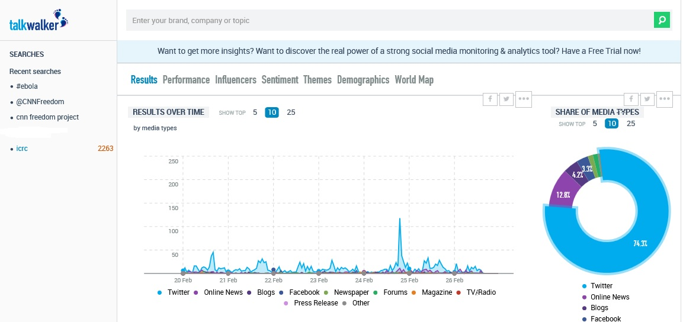

Talkwalker Social Search is a free social search tool that allows you to conduct basic social media analytics with features usually available only in paid tools
How it works:
As an ES officer, you know that social media monitoring consists of daily monitoring (which Hootsuite, for instance, works well in helping you do that) and analytics, which other tools do.
You are also already aware of the two most popular free tools for conducting social media analytics, Social mention and Topsy. These two tools do have certain limitations:
- Limited time frame
- Limited country selection
- Limited filter selection of different types of social content
Talkwalker Social Search appears to be a better replacement for the two popular tools for social media analytics. It offers many features in its free version (there is also a paid version) that provides more filters and functions than other free social media tools.
Let us take a closer look at some of the rich features:
FILTERS:
You can filter your search by media types, countries and language by clicking the “Open Filters” tab at the top of the page. It also shows options to extend your search dates.
- Social media types: You can filter your search through various social media types, from blogs, to Facebook, forums, YouTube, Twitter, Soundcloud, Weibo and others.
- Countries: you can break down your search by continent or counties.
- Languages: Talkwalker Social Search covers close to 190 languages including Arabic, English, Tagalog, French and Chinese.
- Dates: You can also select your date range although seeing anything further back than seven days requires an upgrade to a paid account.
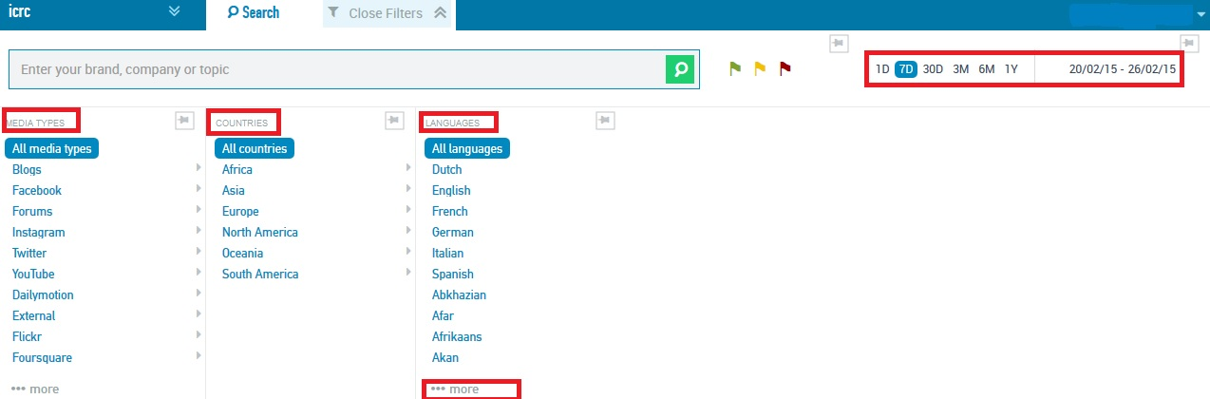
DASHBOARD:
- Underneath the filters section is the analytical section, which allows you to see graphs and to select and view information on all of your search words or just one.
- The graphs are interactive so you can click on the section of the graph to zoom into a specific aspect, whether to see the results from a specific day or to click on the chart and see information only on one search term.
- You can enter additional search terms in the search box at the top of the page. All of your recent searches will appear in the left sidebar. You have a limit of 5 search terms/key words.
- When you click on one of your recent searches, Talkwalker Social Search adds this search result graph to the one you are currently viewing, rather than switching from one to the other. So, you can view multiple search terms at once on the graph by clicking on the search terms in the sidebar (they’ll change color to blue when selected). Simply click the search terms again to unselect them.
Trying and testing the tool allows you to get used how the filtering function works.
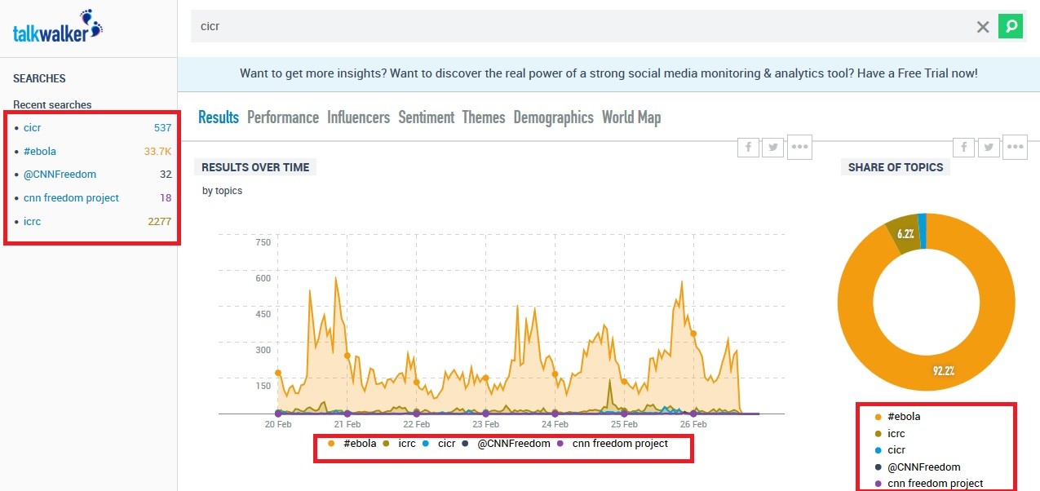
INDIVIDUAL POSTS AND RESULTS
Beneath the graphs on the dashboard, there is a list of every individual post or source that includes your search term. Each listing shows a title, image and preview snippet, along with the potential reach and engagement of that source and the social sharing of the article or post.
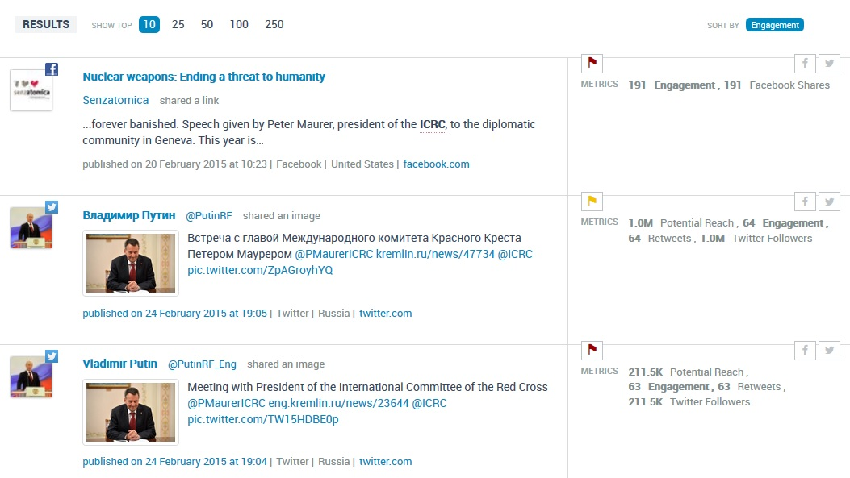

SORTING THROUGH RESULTS
You can sort the list of results through several options such as potential reach or engagement or when the post was published (among other options).
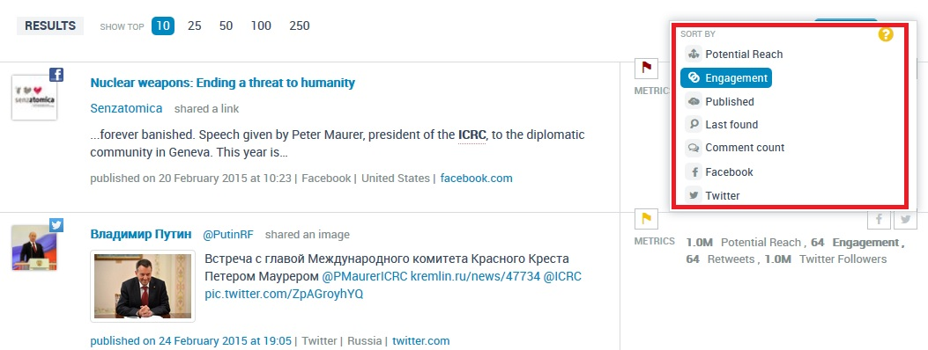
OTHER RELEVANT INFORMATION TO KNOW
There are other tabs across the top of your dashboard, aside from the main Results tab. Here’s a brief overview of these:
- Performance – shows various graphs and metrics indicating the popularity of your search term, such as buzz, engagement, reach and sentiment.
- Influencers – shows the top sites or channels that used the keyword in order of influencer rank, as well as the type of source and the reach.
- Sentiment – shows how many posts were positive, negative or neutral.
- Themes – provides a word cloud showing other terms that commonly appear with your search term.
- Demographics – A list of the top countries and languages using your keyword, as well as a breakdown by gender.
- World map – shows usage of your keyword by country on a map.
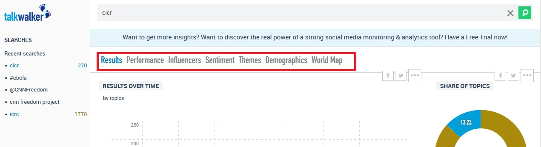

Added value:
- Talkwalker Social Search allows you to conduct social media analytics with features, filters and access to sources that other free tools do not provide.
- This will allow ES officers to have a better overview of the performance of a key word across different platforms and not just one. It will also allow ES officers to compare the performances or visibility of more than one key word at a time.
- This tool allows you to drill down, meaning you can click on graphic elements to see the information behind it.
- It will also provide you with graphical elements that you can attach to your reports or syntheses.
Drawbacks/disadvantages:
- Although Talkwalker Social Search provides more options and filters than Topsy or Social mention for analytics research of your search word on social media, it is severely limited by the fact that you only get information on 7 days.
- Topsy, at least (although it is only limited to Twitter) provides you with social analytics search for 30 days although, Topsy's option does not allow you to drill down and look into the results you get. It only presents a graphic representation of the information, not the ability to see behind that graphic representation.
Tip:
- You can use Boolean search operators like AND, NOT and OR to narrow your search results.
- You can also use quotes around search terms if you want only results containing that exact search term.
Take-away point:
Talkwalker Social Search is a tool that ES officers should try if their social media monitoring needs go beyond daily monitoring and requires analytics. It is not the tool that will allow you to conduct research on a long-term basis (you need the paid version for that) but it can allow ES officers to have an idea of the visibility around a hot topic that is circulating on social media right now.
Talkwalker Social Search: http://www.talkwalker.com/en/social-media-analytics-search/

