TRAK: SEARCHING ON YOUTUBE
- INTRODUCTION
It is possible to search on YouTube. Unfortunately, YouTube itself provides very little documentation on searching on the platform, particularly in relation to search operators that could be prove useful.

The only information on conducting a search mentioned on YouTube’s page is on filtering results. According to YouTube, you can filter results by:
After typing your search query in the search box at the top of any YouTube page, click the Filters drop-down menu below the search box.
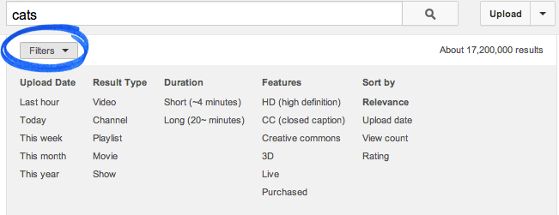
You can filter by the type of content (e.g. video, playlist, or movie). For example, if one cute cat video isn’t enough, you can find an entire playlist of cute cat videos by clicking Playlist under “Result Type” in the Filters drop-down menu.

However, previous experience shows that filtering and sorting does not always provide you with relevant results.

That is why you need advanced search operators (the same that can be found on Google Search) to help you increase your chances of getting relevant results.

- ADVANCED SEARCH: USING OPERATORS TO SEARCH ON YOUTUBE

USING QUOTES
Use “ “ to search exact key words that you want to appear in your search results. For example, the “icrc”

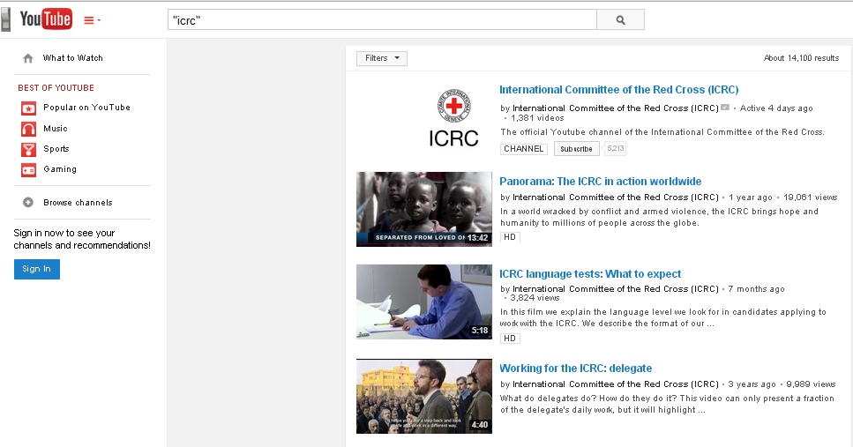

USING the + (plus) SIGN TO FORCE A WORD IN THE RESULTS
The + (plus) and - (minus) signs are both useful for forcing certain results.
The + (plus) sign ensures that your key word is not dropped from the results for whatever reason.
The - (minus) sign can be used to force the YouTube search to exclude any irrelevant but persistent words from the search results.
For example:
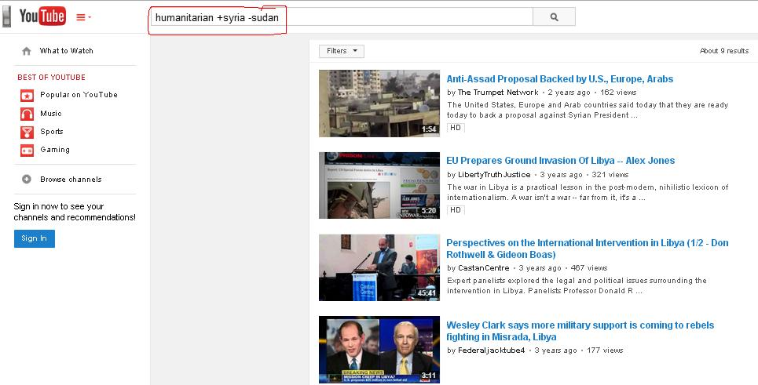

USE The INTITLE:operator to force a word to appear in the video title
This operator allows you to ensure the your keyword appears in the video title. It can be useful in excluding irrelevant results, like for instance, videos that only mention your key word in the comments or loosely in the description.
For example:
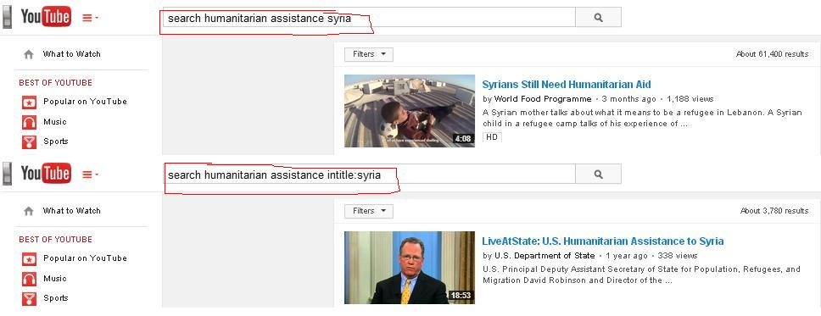

Find a specific YouTube channel
YouTube will have numerous videos related to the ICRC but if you are only looking for the ICRC’s official YouTube channel, add the word channel to your query separated by a comma.

Type in the YouTube search: icrc, channel
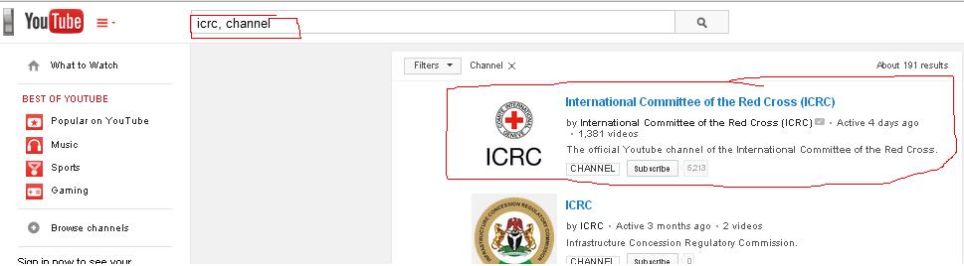

Find high-quality videos on YouTube
Add the keyword hd to your keyword search on YouTube and it will only show high-definition video clips that are either 720p (1280×720) or 1080p (1920×1080 pixels).

Type in the YouTube search: icrc, hd

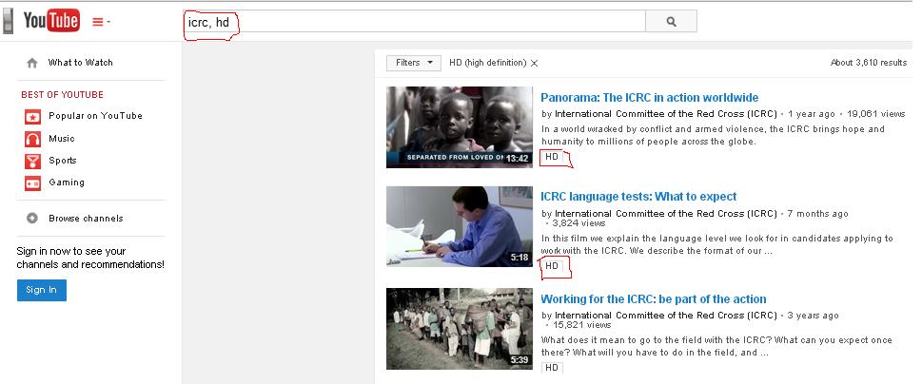

Find video playlists on YouTube
You are able to search for playlists stating that they contain videos related to your keyword. There is also the option to copy the playlists you find to your own YouTube account (see below for more details regarding that).

Type in the YouTube search: icrc, playlist

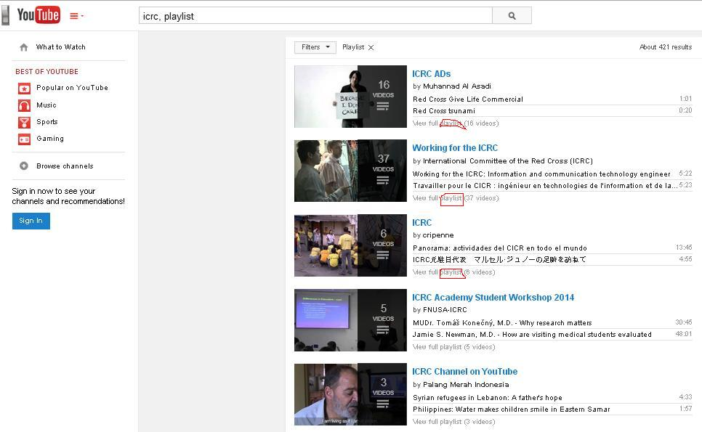

---
Find lengthy videos on YouTube
Add the keyword “long” to your search query and YouTube will only return videos that are at least 20 minutes in length.

Type in the YouTube search: icrc, long
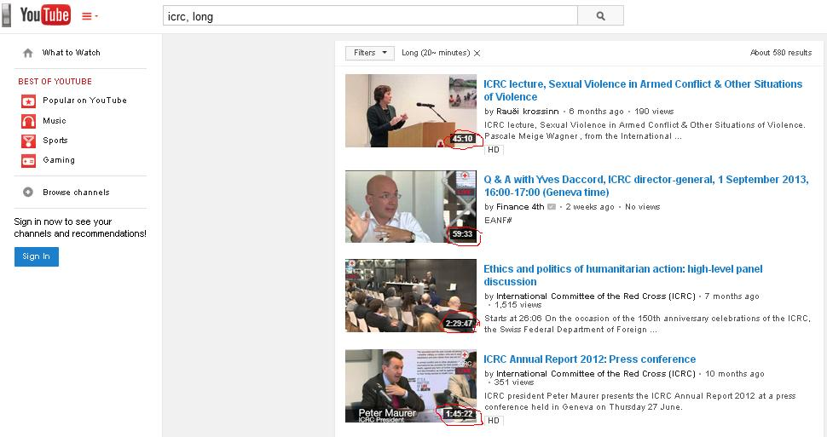

Perform exact-match searches on YouTube
You can also utilize the Google search operator, “allintitle” on YouTube to find results that exactly match your keyword being in the title of the video.

This could be useful for you because the original video might not be available in your country, due to geographic constraints.
Type in the YouTube search: allintitle: “icrc”

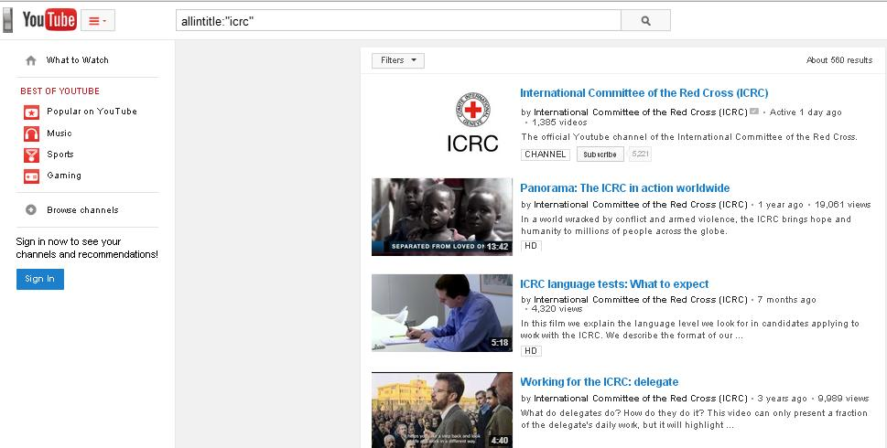

Search WITHIN CAPTIONS
If you would like to search within the captions of videos, all you have to do is to add keyword in the YouTube search field, then a comma and the letters “cc”.

For example, it is useful if you wanted to see videos mentioning a particular term in the videos.

Type in the YouTube search: “icrc”, cc

Mix and Match
Of course, you can always combine (mix and match) all the search operators mentioned above and apply them to the query/search you are conducting. The example below provides you with an idea of how to mix and match.

You can combine all these search operators by using commas (which work much like the Boolean AND operator).

Type in the YouTube search: international red cross, hd, long
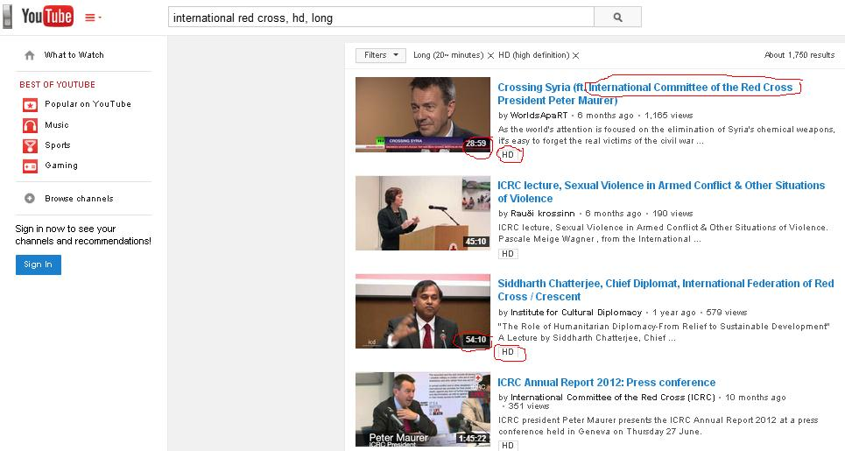

- THIRD PARTY TOOLS FOR SEARCHING ON YOUTUBE
using netvibes to search youtube videos
As Netvibes is one of TRAK’s standard monitoring tools, it can also be used to search for videos, YouTube or otherwise.
Netvibes allows you to conduct a video search using the keywords that you choose.

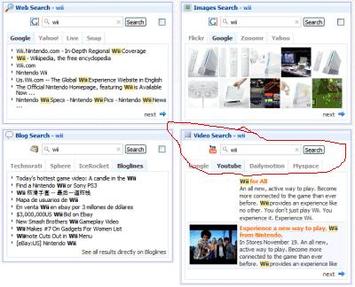

using hootusite to search youtube videos

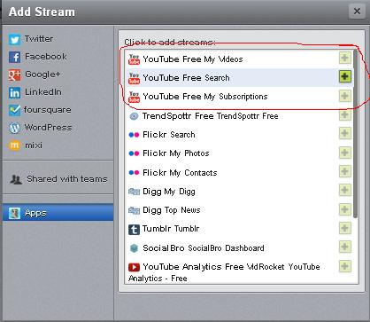

using Google to search youtube videos

Go to Google.com, type your keyword and the parameters you need for your search (i.e. the source or site like youtube.com). See the example below.

Type in the Google.com search: icrc site:youtube.com

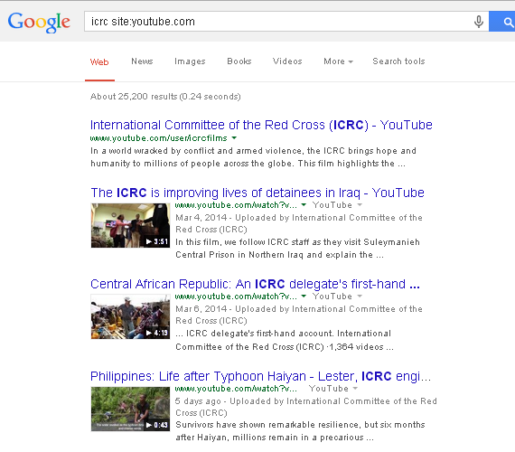
OTHERS
iTools is a search tool for YouTube and Google Video by giving you a clean interface to make use of many of the best tools of the Web.
Source: http://itools.com/tool/youtube-video-search

- HOW TO COPY YOUTUBE PLAYLISTS OF ANOTHER YOUTUBE USER
If you discover a playlist by another YouTube user that you would like to keep after conducting your search, then this option is available to you on YouTube.

This is useful because the playlists can disappear without warning either because the user himself deleted the playlist or YouTube, for one reason, or the other, decides to close the account of the user (i.e. for copyright infringement). So, if the user is gone, so is his/her playlist.

There is a web tool that you can utilize called, the – Copy YouTube Playlists – that will let you copy any playlist to your account (

To get started, sign-in with your YouTube account and allow the app to access your YouTube account. Now enter any YouTube playlist URL (like this one) and set the privacy of your new cloned playlist – it can be either public or private (only visible to you).

When you hit the Submit button, that playlist will be copied to your own YouTube account in 5 seconds.

The web tool is not full-proof in its effectiveness, however, it can prove useful. The idea is to test it yourself to see how useful it is for you.

Please refer to the document on TRAK’s standard social media monitoring tools for the complete list.

