TRAK: Monitoring and Searching in Hootsuite

I. INTRODUCTION

Hootsuite is primarily a social media management system. The user interface for Hootsuite is in the form of a dashboard.

TRAK utilizes it as its main primary media monitoring for the Twitter platform.

Even so, Hootsuite can also be utilized to conduct monitoring on Facebook and YouTube.

II. HOOTSUITE AS A TWITTER MONITORING TOOL

The focus on this document is on the utilization of Hootsuite in monitoring Twitter.

Accordingly, a quick reminder to you that you require a Twitter account in order to sign in to use Hootsuite.

Furthermore, should you wish to include the monitoring of Facebook and YouTube as part of Twitter monitoring tasks, further information is available in the last section of this document.

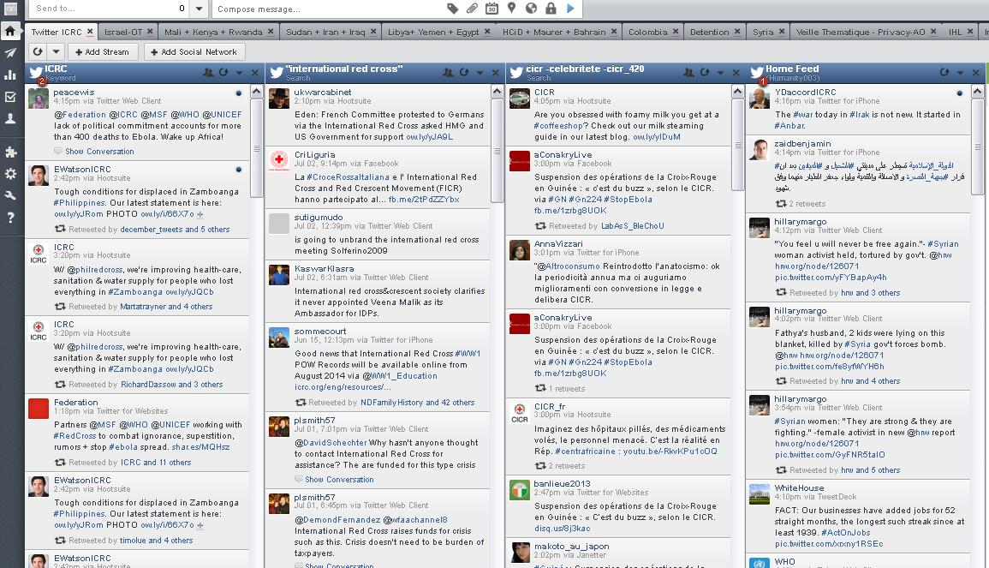

There are two primary search functions in Hootsuite: (1) the Quick Search and (2) the Keyword Search.

III. Using Quick Search in HootSuite
HootSuite has multiple features available to search and sort through the torrent of social media content, but the Quick Search is easily the fastest and most convenient.

You can quickly search a #hashtag, @mention, or keyword in Twitter instantly from the dashboard.

Not only is this a great way to search through Twitter, but you can also save the search results as a stream allowing you to continually monitor your search from the Dashboard.

Here’s how:
- Simply click the search bar (the magnifying glass) on the top right hand side of the screen, type in your search, and press Enter.
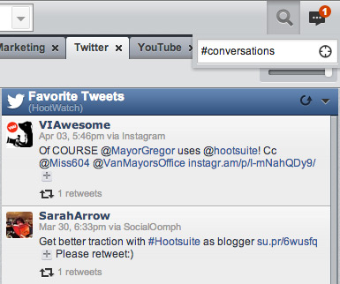
- This will bring up live search results, where you can view the results, or save them as a stream.
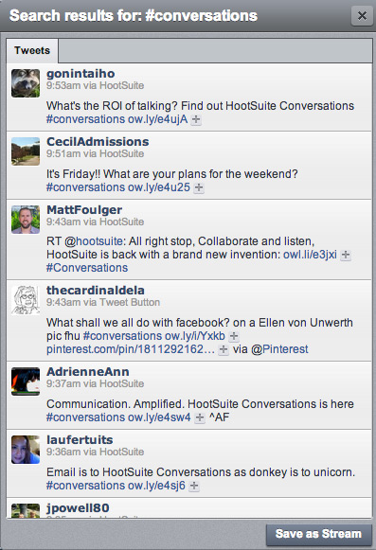
- Once you’ve clicked “Save as Stream”, HootSuite will add that search query into your dashboard for you to keep tabs on at your convenience!
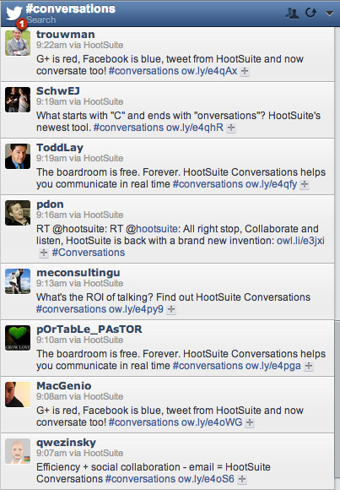
- With the quick search function, you can also search for Twitter users and Facebook public posts (with the option to Save as Stream).
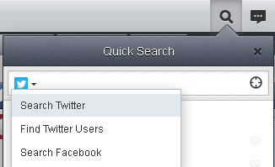

IV. USING KEYWORD SEARCH IN Hootsuite

Keyword search
Go to Add Stream and you’ll see a tab for Search and Keyword.
Hootsuite’s Keyword search allows up to three keywords (or phrases) making it easy to monitor, for example, different spellings of the same company, person or location, or three related hashtags.
You can save the search as a stream, as before, and edit your search by clicking the small arrow at the top of the search stream and Preferences.
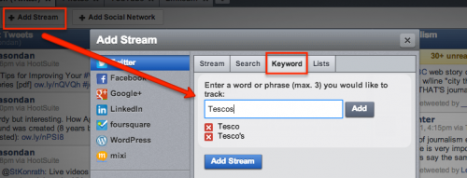
Include up to three keywords in a Hootsuite search without knowledge of advanced operators

Advanced search operators
- After clicking the Add Stream button as above, select the Search tab and you’ll see a window blank except for the geocode icon. You’ll also see a button titled Show Examples. Select it and you’ll see that Hootsuite works with advanced search operators much like Google.

- Besides the obvious “OR” and “exact term” operators, you can eliminate search keywords using a minus sign. You can search for tweets ‘to:’ or ‘from:’ a specific user. The ‘since:’ or ‘until:’ a particular date operator doesn’t give good results.

- The ‘filter:links’ operator is a good one too, helping filter out Twitter chitchat by only looking for tweets with links.
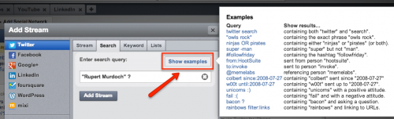

V. filter search results by language

Here’s how:
Simply add a language search parameter (listed below) to the end of your search. With over 20 languages to choose from, it’s easy to find results for #hashtags, @handles and keywords in your language.
This search parameter can be tacked on to any of HootSuite’s search features: Search Streams, Keyword Tracking Streams and Quick Search.

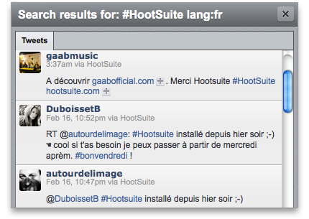

Language Filters
Dutch – lang:nl
Danish – lang:da
English – lang:en
Filipino - lang:fil
Finnish – lang:fi
French – lang:fr
German – lang:de
Hindi – lang:hi
Hungarian – lang:hu
Indonesian – lang:id
Italian – lang:it
Japanese – lang:ja
Korean – lang:ko
Malay – lang:msa
Norwegian – lang:no
Polish – lang:pl
Portuguese – lang:pt
Russian – lang:ru
Simplified Chinese – lang:zh-cn
Spanish – lang:es
Swedish – lang:sv
Traditional Chinese – lang:zh-tw
Turkish – lang:tr

VI. Advanced Twitter Search and filter Examples
Source: https://help.hootsuite.com/entries/22460803-What-are-some-advanced-Twitter-search-examples-
HootSuite's search functionality supports up to 1,000 characters, and is based on Twitter Search. This means Twitter search strings are typically rendered the same way in HootSuite as they are on Twitter.
Here are some examples of advanced search arguments to help you refine your results.
Search queries
Search query | Results
source:Facebook | containing posts coming to Twitter from Facebook
icrc since:2013-01-27 | containing "icrc” sent since "year-month-day"
icrc until:2008-07-27 | containing "icrc" sent up to "year-month-day"
from:cicr_fr | sent from username “cicr_fr”
to:cicr_fr | Sent to username “cicr_fr”
twitter search | containing both "twitter" and "search"
"icrc wins" | containing the exact phrase "icrc wins"
icrc OR sun | containing either "icrc" or "sun" (or both)
icrc -syria | containing "icrc" but not "syria"
icrc min_retweets:number | containing “icrc” with tweets retweeted at least the number of times you put in your search (see example below)
icrc min_favs:number | containing “icrc” with tweets favourited at least the number of times you put in your search (see example below)

Example: icrc min_retweets:number
You can do that by entering your keyword with the search operator min_retweets:number or min_favs:number in the Quick Search area.

1. Go to the Quick Search Button. Enter your search term with the operator (like this example):
icrc min_retweets:50.

2. Press Enter.

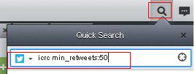

3. This will only show tweets mentioning the icrc in tweets that have been retweeted at least 50 times. Click “Save as Stream” at the bottom right of your Quick Search mini-window.

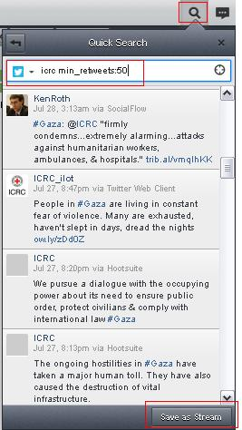
4. You will see your results in a new stream.
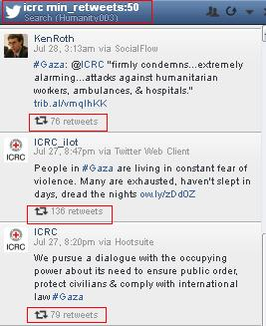

Filter options
Filter query | Results
filter:images | containing all posts with images
filter:links | containing all posts with links
filter:video | containing all posts with videos
filter:text | containing all text-only posts
filter:audio | containing all audio posts
icrc filter:links | containing "icrc" and linking to URLs

VII. SEARCH THE LOCATION NEAR YOU
- Search location near you:
- To conduct a search of a location near you, click on the “quick search icon”, the magnifying glass.
- Enter your search term in the Quick search field.
- Click on the “crosshairs icon” (marked in red in the image below).
- Your twitter stream in each tab will automatically refresh showing local search results within 25km from your current dashboard location.
- ***This is not full-proof and does not always work. Hootsuite is working on improving the feature.

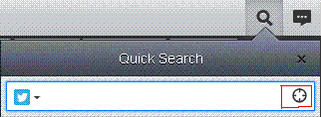

VIII. HOOTSUITE AS A MONITORING TOOL FOR FACEBOOK AND YOUTUBE

Add the YouTube Search App into your Hootsuite dashboard

**Please take note that searching on the YouTube App in the Hootsuite dashboard requires you to be logged into a YouTube account (as is already the case with searching within Twitter, Facebook or any other social media platforms in Hootsuite).**

- Go to the left hand side of your Hootsuite dashboard and click on the App Directory.

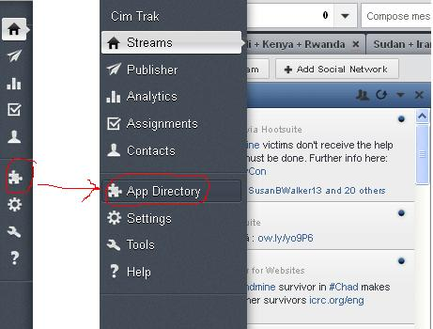

- In the “App Directory”, type in “YouTube”. Select the “YouTube Free” App. Then click on “Install App”.

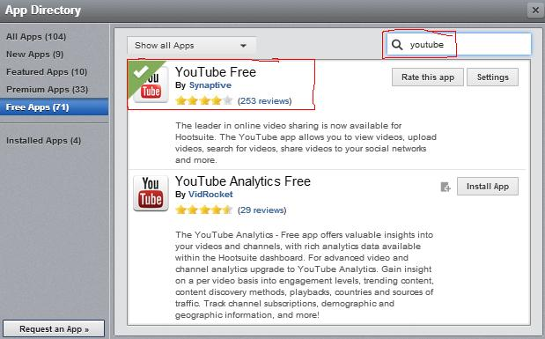

- When you have clicked on the “Install App” button, a window appears asking you two things:
  - The first thing it asks you is to select which YouTube Free streams you wish to view on your dashboard. Select only “YouTube Free – Search”.
  - The second thing it asks you is whether you want to place the YouTube Free App in a new tab or an existing one. You can choose the option that applies best to your particular needs in the moment. Click on “Finish”.

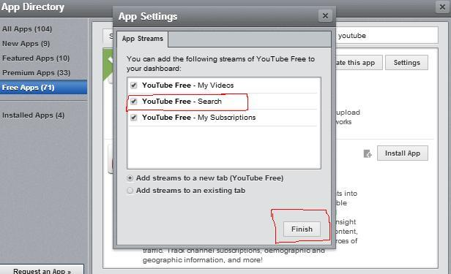

- With the “YouTube Free – Search” App installed, you will have to connect to your YouTube account.

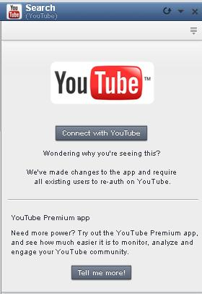

- Enter the search term/key words you wish to explore further. Then click on “Search”.
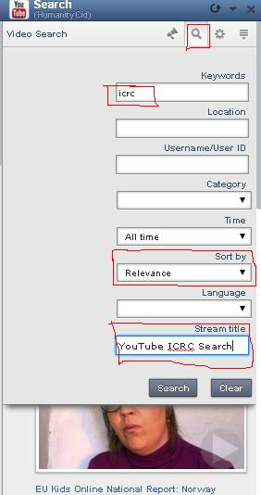

Add the Facebook Search App into your Hootsuite dashboard

**Please take note that searching on Facebook App in the Hootsuite dashboard requires you to be logged into a YouTube account (as is already the case with searching within Twitter, YouTube or any other social media platforms in Hootsuite).**

- To search on Facebook, click on “Add Stream”.

A window will show up with several social media platforms listed to the left, including Facebook. Click on Facebook.
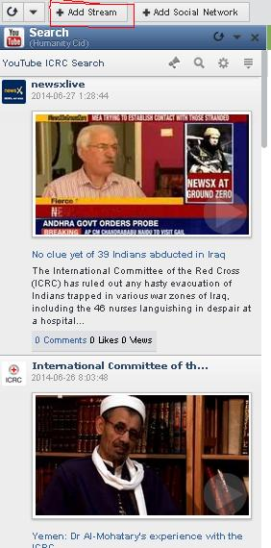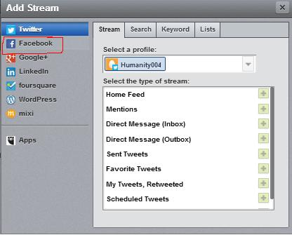

- Add your Facebook profile, if you have not already done so.

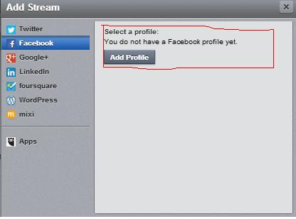

- Click on the “Search” tab. Select your Facebook account. Enter your key word in the field entitled, “enter your search query”. Click “Add Stream”. You will now be able to view your results.

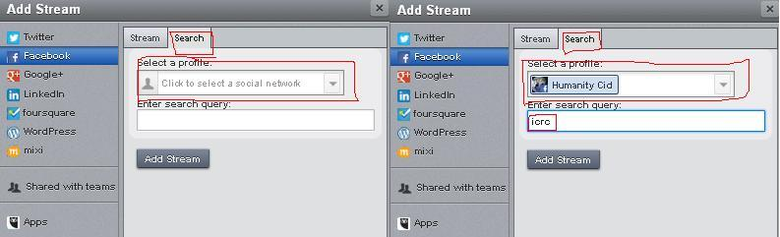

**LIMITATIONS IN USING HOOTSUITE TO MONITOR FACEBOOK AND YOUTUBE**
Hootsuite is an excellent monitoring tool for Twitter.

It also functions relatively well for Facebook and YouTube, however it does so with one particular limitation.

With Twitter, your queries, once you have inputted them into Hootsuite remain until you decide to make changes or remove them altogether.

Contrary to Twitter, Your Facebook and YouTube queries have to be updated regularly. That is to say that Hootsuite does not retain your Facebook and YouTube queries for a long period of time, thus requiring you, if you do not check them often, to re-input your search terms, from time-to-time.

Meaning if you already have an existing tab with queries/searches in a particular subject, then you can choose to have the new Hootsuite Syndicator stream added to that tab. If this is a new subject, then you can have the new Hootsuite Syndicator Stream added to/created in a new tab.

