TRAK Guidelines:
Monitoring on Facebook

INTRODUCTION

Conducting monitoring on Facebook is not as straightforward as it is for other platforms such as Twitter. Facebook functions in a different manner than Twitter in that the majority of information that is shared is done so in private (either with friends, one’s personal network or private groups created for a specific reason). This means that any monitoring that is done is Facebook is only on public pages.

With that said, monitoring on Facebook can be done within Facebook and outside Facebook (with social media monitoring tools). This publication is not about social media monitoring tools for Facebook. The main focus here is on monitoring within the Facebook platform.

Monitoring within Facebook can, at times, mean following a specific page (for an organization) or person (public figure or an eminent figure relating to a particular subject or context). Generally, the evident way of following a public page and having it appear automatically on your news feed is to like the page. Liking the page will automatically subscribe you to the person’s posting, thus updating you on their latest items through your News Feed. In other words, any new item posted from the page you are following will show up in your News Feed.

There is a caveat to liking a page. Your likes are publicly visible. Thus, your liking of the page becomes visible on your profile. There might be times or situations where having a certain group/page/figure publicly visible on your profile or an ICRC profile as someone you or the ICRC follows might not be desirable. So, how then can you monitor/follow a public page without having it attached to your Facebook account or an ICRC-affiliated account?

One particular way is through the use of Interest lists. Keep in mind that the Interest List feature was also created by Facebook as a way to allow the user (that is, you) to have a means of keeping your likes and those you want to follow discreet.

Read on to understand exactly how that functions.

Monitoring pages/profiles on Facebook “without liking a page”

1. INSIDE FACEBOOK – with a Facebook account on the Facebook platform
You can easily trace any Facebook page without liking that page on Facebook.

By doing this, your interests will not be visible. There are two ways of following pages on Facebook. The main way is within Facebook. The other way still requires Facebook although you can opt to have the final result appear in an RSS feed. Read on for further instructions.

2 ways to add people/pages to your interest lists:

ONE – FIRST WAY:
To do this, you only need to add that page in your Interest list. Just like below image. You can add thousands of pages in your interest list and to get latest updates.
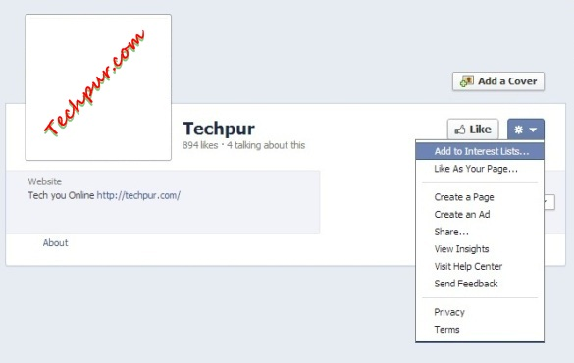
If you do not have any Interest Lists yet, you can click the link to add a “New list”. A pop-up window will appear which walks you through setting up a new list. Interest Lists can be public, shared with friends, or private. In other words, these lists can be set up so that only you can see them.
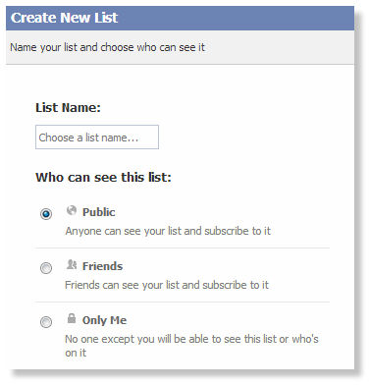
To access your Interest Lists, you go back to your home page/feed (timeline landing page of Facebook) and at the bottom of the left-hand side menu (column), you will see the link to the feed for your interests as shown here:
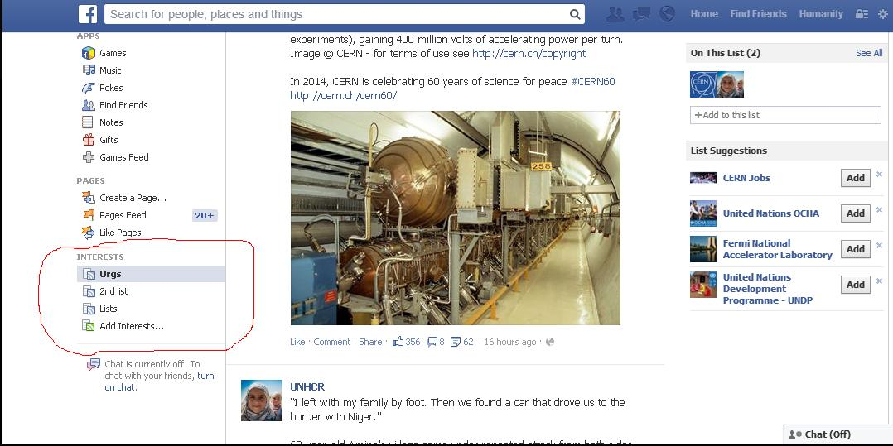
TWO – SECOND WAY
- Go to your Interests page and click the Add Interests button.
- Click Create List.
- Search for the people or Pages you want to add to your list using the search box at the top of the page, or use the categories on the left to browse.
- After you've selected the things you want to include on your list, click Next.
- Pick a name for your list.
- Select a privacy setting. Choose Public if you want others to be able to subscribe to the list you've created.
- Click Done.
If you want to share the information featured in one of the lists you've created or subscribed to, you can share that list with them:
- Go to the list by clicking Home > Interests > More > click on the name of the list
- Click Share at the top of the page
**Note 1**:
You need to visit your Interest lists to see updates related to those pages, Facebook will not display those updates in your home page/News Feed.

**Note 2**:
You don't have to like a Page or follow a person to add them to your list.

THREE – ARCHIVING/SAVING POSTS FOR LATER VIEWING
Facebook has now introduced a new feature called “Save” which allows you to save posts/articles you view on your feeds (whether that is your News Feed or the posts located in your Interest lists). Items you save will show up in their own special section. The options for each post in your news feed will include the ability to save the content (be it a web link, restaurant, album, or anything else) to your Facebook profile for later. When you check your saved items, you'll find them split up by category and ready to be opened, shared, or archived. Facebook will also bug you occasionally if you have saved items that you haven't done anything with.

Let us see how that works.

How to save a post to view it later
To save something you see on Facebook (links, places, music, books, movies and TV shows), do the following:

- Find the thing you want to save.

- From your News Feed/Interest List: click “Save” in the bottom right of a post or click and then select Save. OR
Click on the drop down arrow to the right of your post and click on “Save the name of the post you want to save”. See the examples below.
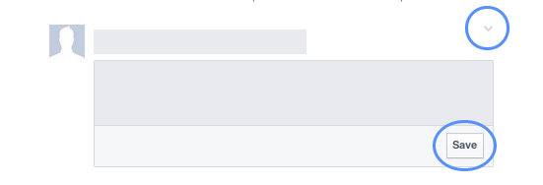

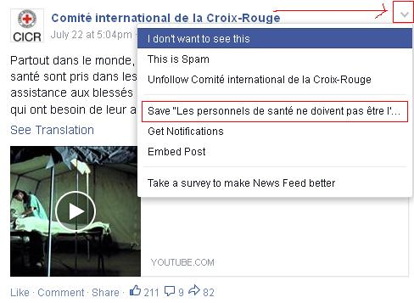

**Note 1**:
Facebook has provided no explanations for this anomaly in the “Save” function but be aware that at times, certain posts cannot be saved (that is to say, the “Save” option does not appear when you click on the post).

How to view saved items/posts
When you save items, they will appear in your “Saved” items list, which only you can view.
To view the items you have saved, do the following:

- From your homepage, click “Saved” in the left column.
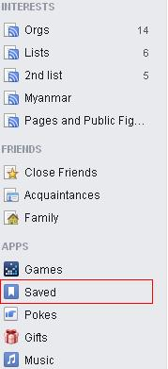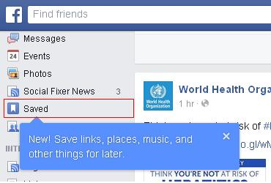

- Click a saved “category” at the top or click “All” to see everything you have saved.

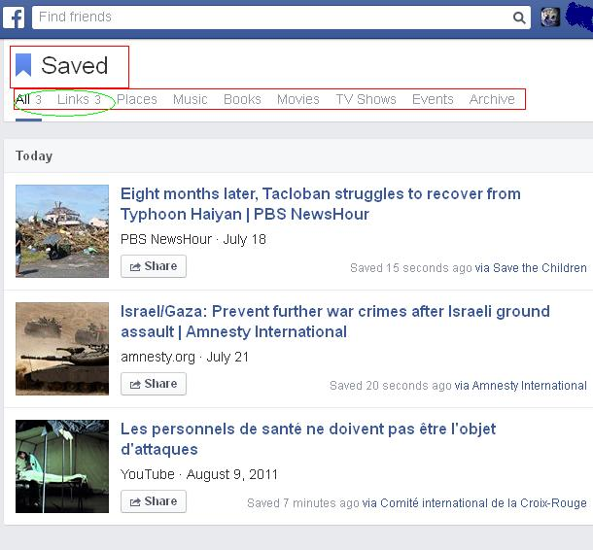

- Click your saved item to view it.

**Note 2**:
The categories for saved items have already been created by Facebook as you can see in the image above. You do not have control over that and you are not able to create your own categories, at least for the moment. Perhaps this is a function that Facebook will add in the future but until then, you will have to work with categories offered by Facebook.

How to archive your saved items/posts
To archive something you've saved from your Saved Items, do the following:

- From your homepage, click “Saved” in the left column.
- Hover over the item you want to archive and click x in the top-right corner.

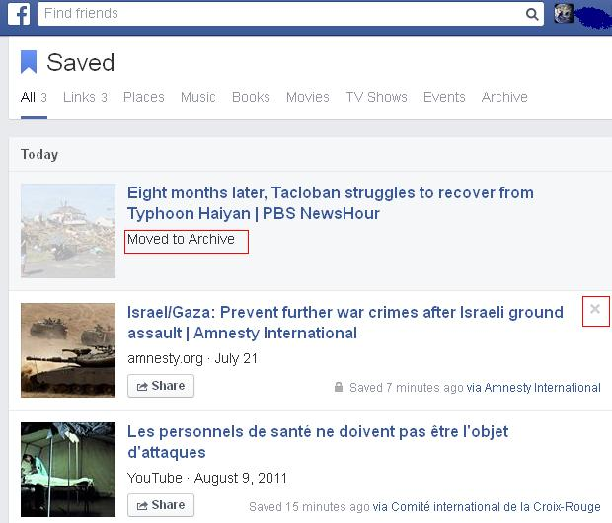

To permanently delete something you have archived previously, do the following:

- From your homepage, click Saved in the left column.
- Click Archive at the top.
- Click “” next to the item you want to permanently remove and then select “Delete”.
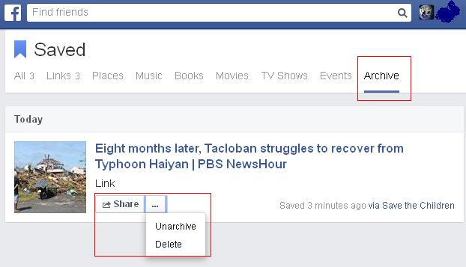

2. OUTSIDE FACEBOOK – without the use of a Facebook account
Monitoring a page or profile outside of the Facebook platform is a bit cumbersome but, nevertheless, doable. See below for instructions on doing so.

Source: http://blogsandpr.com/2013/03/subscribe-to-a-brands-facebook-page-in-an-rss/
Did you know that you can use RSS Feed Readers to follow your favourite Facebook Pages? Today, I’m going to show you a quick method to keep track of Pages without missing their updates, as these could potentially get lost in your busy Facebook newsfeed.
You can then visit the Pages if you wish to comment. This method also makes it possible to keep track of a Facebook page without having to ‘Like’ it first.
Let us use Google RSS Feed Reader in this example.
STEP 1 – Record the following RSS link
Open a new document in Word, Sticky Notes, Notepad or whatever software you normally
use to type your notes.
Copy and paste this link into the new document:
http://www.facebook.com/feeds/page.php?format=atom10&id=PASTE_ID_HERE
Leave this document open. We will come back to it in a few minutes.
STEP 2 – Grab the Facebook Page’s identity number (aka their ID)
A Page’s ID is usually a long number found in their URL. But because most pages have
converted their IDs to a vanity URL, it’s not easy to know their ID (e.g. mine is
www.facebook.com/sillymummydotcom). What we need to do then is convert their URL back
to an ID and insert into the URL we copied in Step 1 above.
Open a new Tab in your browser, and navigate to the Facebook Page you wish to follow.
Copy their URL link.
Click on the following link which should open automatically into a new Tab
http://findmyfacebookid.com/.
Paste the Facebook page URL into the field and press Enter to convert to its ID.
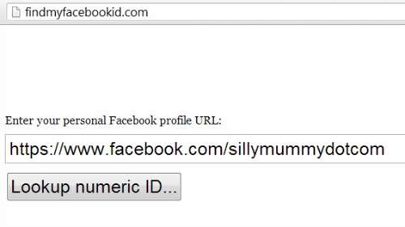
The result should look like this:
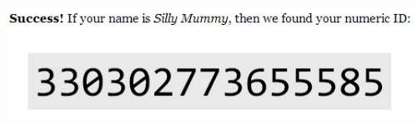
Copy the ID number.
STEP 3 – Go back to your document and modify the URL
Now in your document you will replace PASTE_ID_HERE with the ID number.
It should now look like this
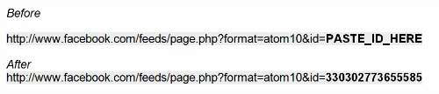
STEP 4 – Subscribe to the Facebook Page
Copy the new link and paste into the Subscribe field in your RSS Feed Reader.

Can you conduct Environment Scanning/monitor on Facebook with its new “keyword” Graph Search?

INTRODUCTION

The answer is mostly no although there could be a “small yes” included in the answer. Let us explain.

As you well know, Facebook has its own native search engine, Graph Search, which allows users to conduct searches inside the platform. Originally, the Graph Search function had little success as it was difficult to use and not intuitive for users. That changed in December 2014 with the addition of a keyword function to its search capabilities.

Facebook users can finally search for posts that have been shared with them and for old Facebook activity on theirs and others’ pages.
This news comes in at the same time that Facebook announced that it has stopped including results from Microsoft's Bing search. (AllFacebook)

DETAILS

How it works: To the right of the search field at the top of the app or website, you can select whether you want to search posts, people, and photos, among other options. Enter a search term you remember from the post (like “funny dog”) and it’ll pull up related results. You can also search without specifying what kind of result you’re looking for, and posts will be listed at the bottom of search results with a magnifying glass icon to the left. Only those posts, which have been shared with friends or pages, can be searched. (Wired)
Added value: From the ES perspective, Facebook's new "keyword" search function, although an interesting development, is not much of a step-forward for ES practitioners. Remember, the search function also works for posts shared in your personal circle. The new feature will not allow you to search all of Facebook (for privacy reasons).
- However, ES practitioners should keep in mind that public posts by personal profiles will not be automatically displayed in search results (even if those posts were tagged as public for anyone to see). At the moment, Facebook Graph Search only shows results from connections. There's one exception, however: If you search for a hashtag, any post using that hashtag can be found and displayed.
- So, despite the results mainly remaining within your social circle, remember that Facebook has now indexed over 1.3 million posts in other to make the "keyword" search function possible so who's to say to what level Facebook will extend its search function. The results could go beyond your social circle into what other people outside your circle are saying. That remains to be seen.
Tip: Using fewer words (just keywords) will likely provide better results than a more specific, longer query.
Note: Results are not displayed in chronological order, so you may have to scroll to find the post you are looking for.

There are other possible alternatives to following a particular page/profile on Facebook but they require resources not necessarily at the disposal of a non-IT professional.
Primary source: http://techpur.com/how-to-follow-or-trace-facebook-page-without-like/

